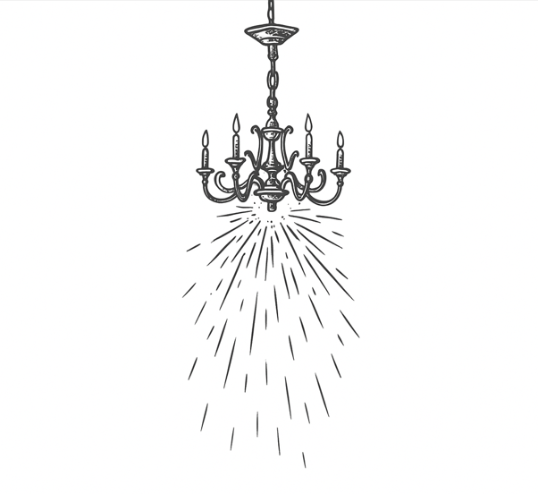
Published in the little journal: romance 2025
by Writing WA in collaboration with Night Parrot Press
proudly supported by Edith Cowan University and Raine Square.

Hearts and Minds
Jen Rewell

They met in an old-fashioned Irish pub which had replica sticky carpets and genuine timber tables protected by thin forcefields.
The host, a mutual friend, was first to introduce them.
“Jule, do you know Misha?” said the elegant pilot, then swanned away to greet another guest.
They suited each other. A frosted glass chandelier above them pulsed with energy as their synapses buzzed in unison.
“Nice to meet you.”
“And you.”
“May I buy you a drink?”
A smile, a twist of the hair, a coy dip of the chin, eyes lowered and raised to look with interest.
“You may.”
Quaint wall-sconces glowed more brightly.

The pub had human bartenders (well-paid cos-players) and retro decor but it was powered by technology that took efficiency to the edge of perfection.
The metropolis grid was powered entirely on electricity produced by its own human residents.
A hyper-sensitive sensor ran through the city and captured minute amounts of energy which were converted via a complex series of transformers.
The sensor detected and gathered static as the people moved about their brightly lit homes and workspaces.
It gathered electrical signals from the sinoatrial node in their hearts.
It collected the millivolts of electrical potentials that pulsed in every human brain as neurotransmitters linked to receptors on postsynaptic neurons.
The city throbbed with energy created by its own population.
The party hummed. The pub’s blood-alcohol monitors were surreptitiously switched off. Drinks flowed and music swelled.
The guestlist was full of mutual friends who had known Jule and Misha, separately, for years.
As the party raged they were introduced to each other several times.
“Have you two met yet?”
“Misha, I’d like you to meet one of my best friends in the whole galaxy, Jule.”
“Do you guys actually know each other? Jule, this is Misha.”
Every time they met there was a jolt of excitement, of possibility, of potential.

The archaic style of the pub had been embraced by its designer, who had studied twenty-first century photos and painstakingly recreated patched walls and beer stains.
There were reproduction tin signs, dado walls, a restored neon sign behind the mirrored bar, and even a nostalgic eight-step staircase which led to nowhere.
The dimly lit stairwell was a deliberate choice by the unknown designer to counter the norm of constant illumination. An antique green “exit” sign glowed softly above the lower doorway.
Misha entered the slim room and walked up the stairs, feeling disconcerted by the lack of anti-gravity platforms.
They traced their fingers on the textured walls as they walked eight steps up, then turned to walk back down.
In the doorway, lit green, was Jule.

A moment to savour.

“Hello. I don’t believe we’ve been introduced,” Misha said, and Jule laughed.
“I think everyone has had a go at it tonight,” Jule ventured. “Perhaps we should get to know each other, if it matters so much to them.”
“A good idea,” Misha agreed lightly, admiring Jule’s silhouetted figure. “It would be the kindest thing to do.”
Jule walked up a few stairs looking up at Misha’s face, then paused and looked down at the stair treads.
“I’ve never been on an actual staircase before,” Jule said.
Misha took three steps down.
“Me neither,” Misha said quietly.
Jule took another step and looked up. Even though Jule was still one step below Misha, they were face to face. Their bodies were almost touching.

A moment.

“I want to kiss you,” whispered Jule. “May I?”
“You may,” Misha breathed, and their Declare Consent bracelets bipped in acknowledgment.

Lips tender, gentle kisses, mouths opened, tongues tasting.
Fingers traced, arms embraced, bodies pressed, soft caressing.
Sudden sweat, mouths hard, breath hot, tongues demanding.
Hands roamed, wet touched, legs weak, overwhelming.

Their bodies entered a complex series of physiological changes mediated by the brain, endocrine and automatic nervous system. Brain activation neurotransmitters released chemicals associated with pleasure and reward. Their amygdala and prefrontal cortices became highly active and their increased heart rates resulted in a sudden increase in vasodilation.

The sensors were overloaded. A massive inductive spike sent a hot energy pulse through the pub. A cascade of feedback climaxed in a buzzing surge of power.
Sparks flew from the wall sconces and showered from the chandeliers onto the crowd. Behind the bar, the neon sign glowed dazzlingly bright.

After the ruckus died down, Jule and Misha emerged from the stairwell, hair mussed and faces flushed.
Later, they were seen leaving the party together, holding hands.

